**Armed Forces Day 2025 Competition**

****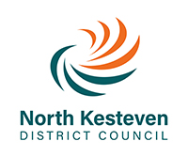

For 2025, in tribute to the contribution our British Armed Forces community make, our competition theme is

**‘80th Anniversary of the end of World War II with VE (Victory in Europe) & VJ (Victory over Japan) Days’,** Using any medium, please draw your original design in the box below, complete the details and return the form to: **Armed Forces Day 2025 Design Competition, North Kesteven District Council, Kesteven Street, Sleaford NG34 7EF or email:** [**armedforces@n-kesteven.gov.uk**](mailto:armedforces@n-kesteven.gov.uk)by the closing date of **Friday 4th April 2025.** The winning designs will be used to promote Armed Forces Day 2025 in North Kesteven.

|  |  |  |  |
| --- | --- | --- | --- |
| Name |  | Age |  |
| School/Contact details: |  | School Year |  |